UNITED STATES
SECURITIES AND EXCHANGE COMMISSION
WASHINGTON, D.C. 20549

FORM 8-K

CURRENT REPORT
Pursuant to Section 13 OR 15(d)
of The Securities Exchange Act of 1934

Date of Report: September 22, 2026
(Date of earliest event reported)

SUN COMMUNITIES, INC.
(Exact Name of Registrant as Specified in its Charter)
Maryland |  |  |  |  |  |  |  |  |  |  |  | 1-12616 |  |  | 38-2730780
(State of Incorporation) |  |  |  |  |  |  |  |  |  |  |  | Commission file number |  |  | (I.R.S. Employer Identification No.)
27777 Franklin Rd. |  |  | Suite 300, |  |  | Southfield, |  |  | Michigan |  |  |  |  |  | 48034
(Address of Principal Executive Offices) |  |  |  |  |  |  |  |  |  |  |  |  |  |  | (Zip Code)
(248) 208-2500
(Registrant’s telephone number, including area code)

Check the appropriate box below if the Form 8-K filing is intended to simultaneously satisfy the filing obligation of the registrant under any of the following provisions:

☐ Written communications pursuant to Rule 425 under the Securities Act (17 CFR 230.425)

☐ Soliciting material pursuant to Rule 14a-12 under the Exchange Act (17 CFR 240.14a-12)

☐ Pre-commencement communications pursuant to Rule 14d-2(b) under the Exchange Act (17 CFR 240.14d-2(b))

☐ Pre-commencement communications pursuant to Rule 13e-4(c) under the Exchange Act (17 CFR 240.13e-4(c))

Securities registered pursuant to Section 12(b) of the Act:
Title of each class |  |  |  |  |  | Trading Symbol(s) |  |  |  |  |  | Name of each exchange on which registered
Common Stock, $0.01 par value |  |  |  |  |  | SUI |  |  |  |  |  | New York Stock Exchange

Indicate by check mark whether the Registrant is an emerging growth company as defined in Rule 405 of the Securities Act of 1933 (§230.405 of this chapter) or Rule 12b-2 of the Securities Exchange Act of 1934 (§240.12b-2 of this chapter):

☐ Emerging growth company

If an emerging growth company, indicate by check mark if the Registrant has elected not to use the extended transition period for complying with any new or revised financial accounting standards provided pursuant to Section 13(a) of the Exchange Act. ☐

Item 2.01 |  |  | Completion of Acquisition or Disposition of Assets.
On September 22, 2026, Sun Communities, Inc. (the “Company”) completed the closing of the previously announced sale of the outstanding equity of the subsidiaries (collectively, “Park Holidays” or “the UK business”) through which the Company operated all of its business in the United Kingdom (the “Park Holidays Sale” or the “Transaction”). As previously disclosed in the Current Report on Form 8-K filed by the Company with the Securities and Exchange Commission (the “SEC”) on May 21, 2026, and amended on May 28, 2026, the disposition was pursuant to an agreement dated May 21, 2026 (the “Purchase Agreement”), between Sun Communities Operating Limited Partnership, on behalf of itself and two of its subsidiaries, and Panther Bidco Limited (the “Buyer”, which is an affiliate of Aermont Capital LLP).

At the closing of the Transaction, the Buyer paid the Company cash consideration of approximately £772.3 million (or approximately $1.05 billion). The net proceeds to the Company were approximately $1.03 billion, net of closing and transaction costs.

Item 7.01 |  |  | Regulation FD Disclosure.
On September 22, 2026, the Company issued a press release announcing the completion of the closing of the Transaction, a copy of which is attached hereto as Exhibit 99.1, and which is incorporated herein by reference solely for the purposes of this Item 7.01 disclosure. The information contained in such press releases shall not be deemed “filed” for purposes of Section 18 of the Securities Exchange Act of 1934, as amended (the “Exchange Act”), or incorporated by reference into any filing under the Securities Act of 1933, as amended (the “Securities Act”), or the Exchange Act, except as otherwise expressly stated in such filing.

CAUTIONARY STATEMENT REGARDING FORWARD-LOOKING STATEMENTS

This Current Report contains various “forward-looking statements” within the meaning of the Securities Act and the Exchange Act and the Company intends that such forward-looking statements will be subject to the safe harbors created thereby. For this purpose, any statements contained in this document that relate to expectations, beliefs, projections, future plans and strategies, trends or prospective events or developments, and similar expressions concerning matters that are not historical facts are deemed to be forward-looking statements. Words such as “forecasts,” “intend,” “goal,” “estimate,” “expect,” “project,” “projections,” “plans,” “predicts,” “potential,” “seeks,” “anticipates,” “should,” “could,” “may,” “will,” “designed to,” “foreseeable future,” “believe,” “scheduled,” “guidance”, “target” and similar expressions are intended to identify forward-looking statements, although not all forward-looking statements contain these words. These forward-looking statements reflect the Company’s current views with respect to future events and financial performance, but involve known and unknown risks, uncertainties and other factors, both general and specific to the matters discussed in or incorporated herein, some of which are beyond the Company’s control. These risks, uncertainties and other factors may cause the Company’s actual results to be materially different from any future results expressed or implied by such forward-looking statements. In addition to the risks described under “Risk Factors” contained in the Company’s Annual Report on Form 10-K for the year ended December 31, 2025, in Item 8.01 of the Company’s Current Report on Form 8-K filed May 21, 2026, in Part II, Item 1A. in the Company’s Quarterly Report on Form 10-Q for the three months ended June 30, 2026, and in the Company’s other filings with the SEC from time to time, such risks, uncertainties and other factors include but are not limited to:

∙ |  |  | The final costs, adjustments, and net proceeds related to the completed sale of Park Holidays;
∙ |  |  | Our ability to realize the anticipated benefits of the completed sale of Park Holidays, including with respect to the intended use of proceeds;
∙ |  |  | Our ability to deploy the proceeds from the Park Holidays Sale in a timely and value-accretive manner;
∙ |  |  | Our liquidity and refinancing demands;
∙ |  |  | Our ability to obtain or refinance maturing debt;
∙ |  |  | Our ability to maintain compliance with covenants contained in our debt facilities and our unsecured notes;
∙ |  |  | Availability of capital;
∙ |  |  | General volatility of the capital markets and the market price of shares of our capital stock;
∙ |  |  | The timing, manner, and amount of any repurchases under the Company’s share repurchase program;
∙ |  |  | Increases in interest rates and operating costs, including insurance premiums, real estate taxes, and utilities;
∙ |  |  | Difficulties in our ability to evaluate, finance, complete and integrate acquisitions, developments and expansions successfully;
∙ |  |  | Competitive market forces;
∙ |  |  | The ability of purchasers of manufactured homes to obtain financing;
∙ |  |  | The level of repossessions of manufactured homes;
∙ |  |  | Our ability to maintain effective internal control over financial reporting and disclosure controls and procedures;
∙ |  |  | Expectations regarding the amount or frequency of impairment losses;
∙ |  |  | Changes in general economic conditions, including inflation, deflation, energy costs, the real estate industry, the effects of tariffs or threats of tariffs, wars or other international conflicts, trade wars, immigration issues, supply chain disruptions, and the markets within which we operate;
∙ |  |  | Changes in foreign currency exchange rates, including between the U.S. dollar and each of the British pound sterling, Canadian dollar, and Australian dollar;
∙ |  |  | Our ability to maintain our status as a REIT;
∙ |  |  | Changes in real estate and zoning laws and regulations;
∙ |  |  | Our ability to maintain rental rates and occupancy levels;
∙ |  |  | Legislative or regulatory changes, including changes to laws governing the taxation of REITs;
∙ |  |  | Outbreaks of disease and related restrictions on business operations;
∙ |  |  | Risks related to natural disasters such as hurricanes, earthquakes, floods, droughts, and wildfires; and
∙ |  |  | Litigation, judgments or settlements, including costs associated with prosecuting or defending claims and any adverse outcomes.

Readers are cautioned not to place undue reliance on these forward-looking statements, which speak only as of the date the statement was made. The Company undertakes no obligation to publicly update or revise any forward-looking statements included or incorporated by reference into this document, whether as a result of new information, future events, changes in the Company's expectations or otherwise, except as required by law.

Although the Company believes that the expectations reflected in the forward-looking statements are reasonable, the Company cannot guarantee future results, levels of activity, performance or achievements. All written and oral forward-looking statements attributable to the Company or persons acting on the Company’s behalf are qualified in their entirety by these cautionary statements.

Item 9.01 |  |  | Financial Statements and Exhibits.
(b) Pro Forma Financial Information

The following unaudited pro forma financial information of the Company, which reflect the sale of the Company’s interests in the UK business to the Buyer, are attached as Exhibit 99.2 to this Current Report. The information contained in these pro forma financial statements shall not be deemed “filed” for purposes of Section 18 of the Exchange Act or incorporated by reference into any filing under the Securities Act or the Exchange Act, except as otherwise expressly stated in such filing.

•Unaudited Pro Forma Condensed Consolidated Balance Sheet as of June 30, 2026
•Unaudited Pro Forma Condensed Consolidated Statement of Operations for the six months ended June 30, 2026 and each of the years ended December 31, 2025, 2024, and 2023
•Notes to the Unaudited Pro Forma Condensed Consolidated Financial Statements

(d) Exhibits.

Exhibit No. |  |  | Description

99.1 Press Release dated September 22, 2026 regarding the closing of the Park Holidays Sale
99.2 Unaudited Pro Forma Condensed Consolidated Financial Statements of Sun Communities, Inc.
104 Cover Page Interactive Data File (embedded within the Inline XBRL document)

SIGNATURES

Pursuant to the requirements of the Securities Exchange Act of 1934, the Registrant has duly caused this Report to be signed on its behalf by the undersigned hereunto duly authorized.
 |  |  |  |  |  | SUN COMMUNITIES, INC.
Dated: September 23, 2026 |  |  |  |  |  | By: |  |  | /s/ Ileana McAlary
 |  |  |  |  |  |  |  |  | Ileana McAlary, General Counsel, Executive Vice President, and Secretary

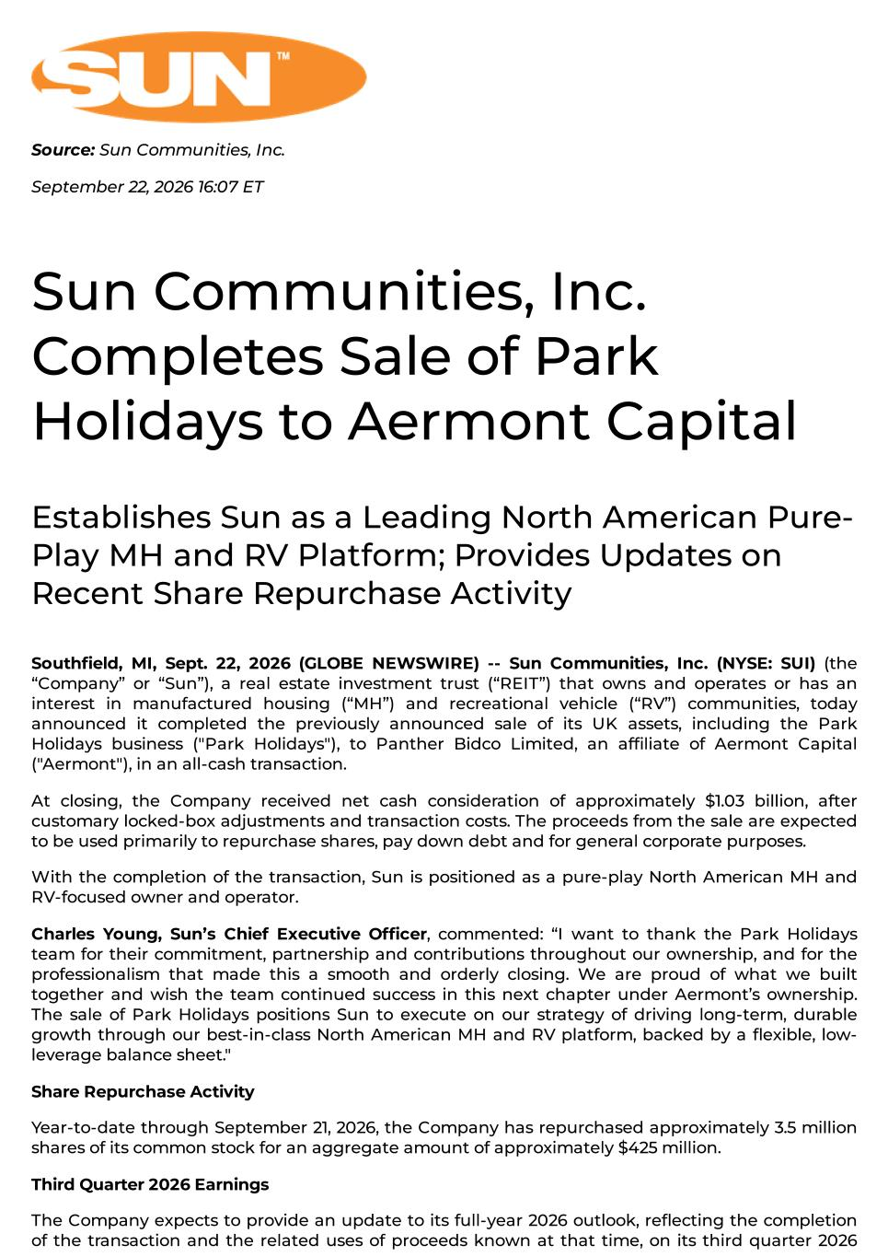

Source: Sun Communities, Inc. September 22, 2026 16:07 ET Sun Communities, Inc. Completes Sale of Park Holidays to Aermont Capital Establishes Sun as a Leading North American Pure- Play MH and RV Platform; Provides Updates on Recent Share Repurchase Activity Southfield, MI, Sept. 22, 2026 (GLOBE NEWSWIRE) -- Sun Communities, Inc. (NYSE: SUI) (the “Company” or “Sun”), a real estate investment trust (“REIT”) that owns and operates or has an interest in manufactured housing (“MH”) and recreational vehicle (“RV”) communities, today announced it completed the previously announced sale of its UK assets, including the Park Holidays business ("Park Holidays"), to Panther Bidco Limited, an affiliate of Aermont Capital ("Aermont"), in an all-cash transaction. At closing, the Company received net cash consideration of approximately $1.03 billion, after customary locked-box adjustments and transaction costs. The proceeds from the sale are expected to be used primarily to repurchase shares, pay down debt and for general corporate purposes. With the completion of the transaction, Sun is positioned as a pure-play North American MH and RV-focused owner and operator. Charles Young, Sun’s Chief Executive Officer, commented: “I want to thank the Park Holidays team for their commitment, partnership and contributions throughout our ownership, and for the professionalism that made this a smooth and orderly closing. We are proud of what we built together and wish the team continued success in this next chapter under Aermont’s ownership. The sale of Park Holidays positions Sun to execute on our strategy of driving long-term, durable growth through our best-in-class North American MH and RV platform, backed by a flexible, low- leverage balance sheet." Share Repurchase Activity Year-to-date through September 21, 2026, the Company has repurchased approximately 3.5 million shares of its common stock for an aggregate amount of approximately $425 million. Third Quarter 2026 Earnings The Company expects to provide an update to its full-year 2026 outlook, reflecting the completion of the transaction and the related uses of proceeds known at that time, on its third quarter 2026

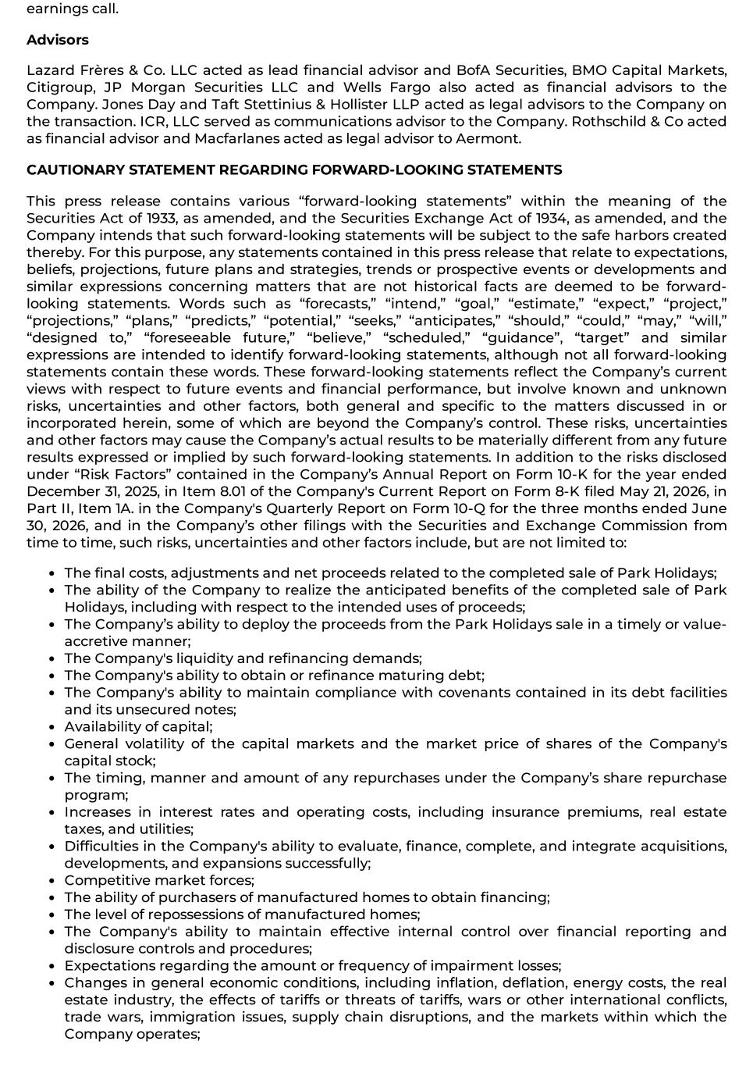
earnings call. Advisors Lazard Frères & Co. LLC acted as lead financial advisor and BofA Securities, BMO Capital Markets, Citigroup, JP Morgan Securities LLC and Wells Fargo also acted as financial advisors to the Company. Jones Day and Taft Stettinius & Hollister LLP acted as legal advisors to the Company on the transaction. ICR, LLC served as communications advisor to the Company. Rothschild & Co acted as financial advisor and Macfarlanes acted as legal advisor to Aermont. CAUTIONARY STATEMENT REGARDING FORWARD-LOOKING STATEMENTS This press release contains various “forward-looking statements” within the meaning of the Securities Act of 1933, as amended, and the Securities Exchange Act of 1934, as amended, and the Company intends that such forward-looking statements will be subject to the safe harbors created thereby. For this purpose, any statements contained in this press release that relate to expectations, beliefs, projections, future plans and strategies, trends or prospective events or developments and similar expressions concerning matters that are not historical facts are deemed to be forward- looking statements. Words such as “forecasts,” “intend,” “goal,” “estimate,” “expect,” “project,” “projections,” “plans,” “predicts,” “potential,” “seeks,” “anticipates,” “should,” “could,” “may,” “will,” “designed to,” “foreseeable future,” “believe,” “scheduled,” “guidance”, “target” and similar expressions are intended to identify forward-looking statements, although not all forward-looking statements contain these words. These forward-looking statements reflect the Company’s current views with respect to future events and financial performance, but involve known and unknown risks, uncertainties and other factors, both general and specific to the matters discussed in or incorporated herein, some of which are beyond the Company’s control. These risks, uncertainties and other factors may cause the Company’s actual results to be materially different from any future results expressed or implied by such forward-looking statements. In addition to the risks disclosed under “Risk Factors” contained in the Company’s Annual Report on Form 10-K for the year ended December 31, 2025, in Item 8.01 of the Company's Current Report on Form 8-K filed May 21, 2026, in Part II, Item 1A. in the Company's Quarterly Report on Form 10-Q for the three months ended June 30, 2026, and in the Company’s other filings with the Securities and Exchange Commission from time to time, such risks, uncertainties and other factors include, but are not limited to: The final costs, adjustments and net proceeds related to the completed sale of Park Holidays; The ability of the Company to realize the anticipated benefits of the completed sale of Park Holidays, including with respect to the intended uses of proceeds; The Company’s ability to deploy the proceeds from the Park Holidays sale in a timely or value- accretive manner; The Company's liquidity and refinancing demands; The Company's ability to obtain or refinance maturing debt; The Company's ability to maintain compliance with covenants contained in its debt facilities and its unsecured notes; Availability of capital; General volatility of the capital markets and the market price of shares of the Company's capital stock; The timing, manner and amount of any repurchases under the Company’s share repurchase program; Increases in interest rates and operating costs, including insurance premiums, real estate taxes, and utilities; Difficulties in the Company's ability to evaluate, finance, complete, and integrate acquisitions, developments, and expansions successfully; Competitive market forces; The ability of purchasers of manufactured homes to obtain financing; The level of repossessions of manufactured homes; The Company's ability to maintain effective internal control over financial reporting and disclosure controls and procedures; Expectations regarding the amount or frequency of impairment losses; Changes in general economic conditions, including inflation, deflation, energy costs, the real estate industry, the effects of tariffs or threats of tariffs, wars or other international conflicts, trade wars, immigration issues, supply chain disruptions, and the markets within which the Company operates;

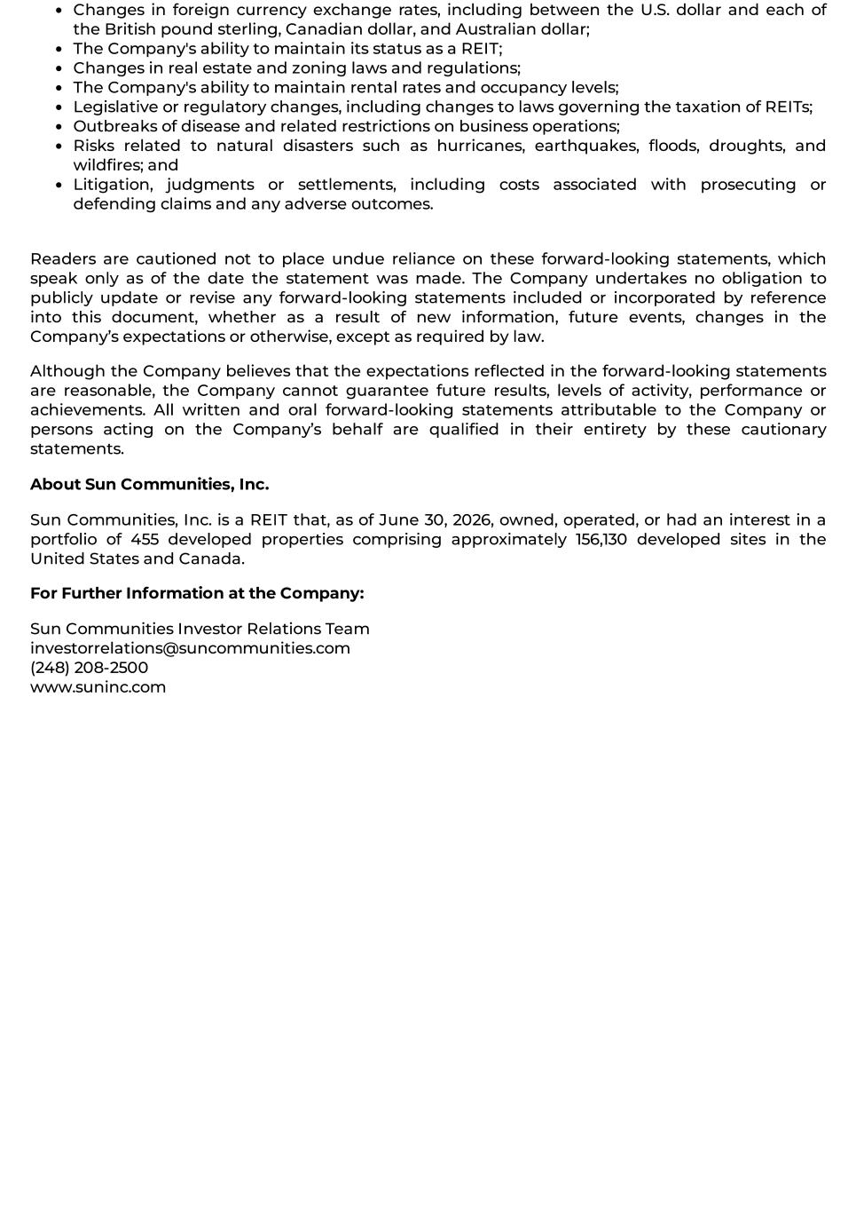
Changes in foreign currency exchange rates, including between the U.S. dollar and each of the British pound sterling, Canadian dollar, and Australian dollar; The Company's ability to maintain its status as a REIT; Changes in real estate and zoning laws and regulations; The Company's ability to maintain rental rates and occupancy levels; Legislative or regulatory changes, including changes to laws governing the taxation of REITs; Outbreaks of disease and related restrictions on business operations; Risks related to natural disasters such as hurricanes, earthquakes, floods, droughts, and wildfires; and Litigation, judgments or settlements, including costs associated with prosecuting or defending claims and any adverse outcomes. Readers are cautioned not to place undue reliance on these forward-looking statements, which speak only as of the date the statement was made. The Company undertakes no obligation to publicly update or revise any forward-looking statements included or incorporated by reference into this document, whether as a result of new information, future events, changes in the Company’s expectations or otherwise, except as required by law. Although the Company believes that the expectations reflected in the forward-looking statements are reasonable, the Company cannot guarantee future results, levels of activity, performance or achievements. All written and oral forward-looking statements attributable to the Company or persons acting on the Company’s behalf are qualified in their entirety by these cautionary statements. About Sun Communities, Inc. Sun Communities, Inc. is a REIT that, as of June 30, 2026, owned, operated, or had an interest in a portfolio of 455 developed properties comprising approximately 156,130 developed sites in the United States and Canada. For Further Information at the Company: Sun Communities Investor Relations Team investorrelations@suncommunities.com (248) 208-2500 www.suninc.com

Sun Communities, Inc.
Unaudited Pro Forma Condensed Consolidated Financial Statements
On September 22, 2026, Sun Communities, Inc. (the “Company”) completed the closing of the previously announced sale of the outstanding equity of the subsidiaries (collectively, “Park Holidays” or “the UK business”) through which the Company operated all of its business in the United Kingdom (the “Park Holidays Sale” or the “Transaction”). As previously disclosed in the Current Report on Form 8-K filed by the Company with the Securities and Exchange Commission (the “SEC”) on May 21, 2026, and amended on May 28, 2026, the disposition was pursuant to an agreement dated May 21, 2026 (the “Purchase Agreement”), between Sun Communities Operating Limited Partnership, on behalf of itself and two of its subsidiaries (collectively, the “Sellers”), and Panther Bidco Limited (the “Buyer”, which is an affiliate of Aermont Capital LLP).
The base consideration amount for the Transaction was £785.7 million (or approximately $1.07 billion), subject to certain customary locked box adjustments, inclusive of the cash profits of Park Holidays up to the completion of the transaction. At the closing of the Transaction, the Buyer paid the Company cash consideration of approximately £772.3 million (or approximately $1.05 billion). The net proceeds to the Company were approximately $1.03 billion, net of closing and transaction costs.
The Transaction constitutes a significant disposition for purposes of Item 2.01 of Form 8-K. The Company has also determined that the UK business has met the criteria under Accounting Standards Codification 205-20, Presentation of Financial Statements – Discontinued Operations (“ASC 205-20”) to be classified as a discontinued operation, as the sale of the UK business represents a strategic shift that will have a significant effect on the Company’s operations and financial results. Accordingly, the Company has accounted for the UK business as a discontinued operation beginning in its Quarterly Report on Form 10-Q for the quarter ended June 30, 2026.
The unaudited pro forma condensed consolidated financial statements presented below have been prepared in accordance with Article 11 of Regulation S-X and were derived from the Company’s historical consolidated financial statements. The unaudited pro forma condensed consolidated balance sheet as of June 30, 2026 reflects the Transaction as if it occurred on such date. The unaudited pro forma condensed consolidated statements of operations for the six months ended June 30, 2026 and for each of the years ended December 31, 2025, 2024, and 2023 reflect the Transaction as if it occurred on January 1, 2023.
The unaudited pro forma condensed consolidated financial statements and the accompanying notes should be read in conjunction with:
–The Company’s Annual Report on Form 10-K for the year ended December 31, 2025, filed with the SEC on February 25, 2026; and
–The Company’s Quarterly Report on Form 10-Q for the three months ended March 31, 2026, filed with the SEC on April 28, 2026; and
–The Company’s Quarterly Report on Form 10-Q for the three months ended June 30, 2026, filed with the SEC on July 28, 2026.
The unaudited pro forma condensed consolidated balance sheet as of June 30, 2026 and the unaudited pro forma condensed consolidated statements of operations for the six months ended June 30, 2026 and for the years ended December 31, 2025, 2024, and 2023 reflect “Pro Forma Adjustments” that are incremental to those related to the Transaction and discontinued operations presentation of the UK business, as discussed above. The Pro Forma Adjustments are described in the accompanying notes to the unaudited pro forma condensed consolidated financial statements.
As previously announced, on April 30, 2025, the Company completed the initial closing of the sale of Safe Harbor Marinas, LLC and SHM TRS, LLC (collectively, “Safe Harbor”) for an aggregate purchase price of $5.65 billion, subject to certain adjustments (the “Safe Harbor Sale”). The Safe Harbor business was classified as a discontinued operation in our Form 10-K for the year ended December 31, 2025 and is therefore not included in our historical results attributable to continuing operations in the accompanying unaudited pro forma condensed consolidated financial statements. During the year ended December 31, 2025, the Company used proceeds from the Safe Harbor Sale to settle approximately $3.3 billion of debt obligations (the “Debt Repayment”). To maintain consistency and continuity with the unaudited pro forma condensed consolidated financial statements associated with the Safe Harbor Sale, disclosed in the Current Report on Form 8-K filed with the SEC on May 6, 2025, we have included pro forma adjustments related to the Debt Repayment in the accompanying schedules. These pro forma debt adjustments are not attributable to the Park Holidays Sale and are included to reflect the impact of the Debt Repayment, which is already reflected in the Company’s capital structure following the Safe Harbor Sale.
The unaudited pro forma condensed consolidated financial information is provided for informational purposes only and does not purport to represent the Company’s actual financial condition or results of operations had the Transaction occurred on the dates indicated, nor does it project the Company’s results of operations or financial condition for any future period or date. The Company has prepared the unaudited pro forma condensed consolidated financial information based on available information using certain assumptions that it believes are reasonable. As a result, the actual results reported by the Company in periods following the Transaction may differ materially from this unaudited pro forma condensed consolidated financial information.

1
Sun Communities, Inc.
Pro Forma Condensed Consolidated Balance Sheet
(Unaudited)
As of June 30, 2026
(In millions, except for per share amounts)

 |  |  |  |  |  |  |  |  | Transaction Accounting Adjustments
 |  |  | Company Historical |  |  |  |  |  | Disposition Adjustments (Note 2(a)) |  |  |  |  |  | Additional Transaction Accounting Adjustments |  |  |  |  |  | Pro  Forma
Assets
Land |  |  | $ | 1,793.8 |  |  |  |  | $ | — |  |  |  |  | $ | — |  |  |  |  | $ | 1,793.8
Land improvements and buildings |  |  | 8,733.9 |  |  |  |  |  | — |  |  |  |  |  | — |  |  |  |  |  | 8,733.9
Rental homes and improvements |  |  | 998.3 |  |  |  |  |  | — |  |  |  |  |  | — |  |  |  |  |  | 998.3
Furniture, fixtures and equipment |  |  | 687.2 |  |  |  |  |  | — |  |  |  |  |  | — |  |  |  |  |  | 687.2
Investment property |  |  | 12,213.2 |  |  |  |  |  | — |  |  |  |  |  | — |  |  |  |  |  | 12,213.2
Accumulated depreciation |  |  | (3,702.0) |  |  |  |  |  | — |  |  |  |  |  | — |  |  |  |  |  | (3,702.0)
Investment property, net |  |  | 8,511.2 |  |  |  |  |  | — |  |  |  |  |  | — |  |  |  |  |  | 8,511.2
Cash, cash equivalents and restricted cash |  |  | 165.2 |  |  |  |  |  | — |  |  |  |  |  | 1,032.8 |  |  | 2(b) |  |  | 1,198.0
Inventory of manufactured homes |  |  | 75.7 |  |  |  |  |  | — |  |  |  |  |  | — |  |  |  |  |  | 75.7
Notes and other receivables, net |  |  | 282.4 |  |  |  |  |  | — |  |  |  |  |  | — |  |  |  |  |  | 282.4
Collateralized receivables, net |  |  | 39.2 |  |  |  |  |  | — |  |  |  |  |  | — |  |  |  |  |  | 39.2
Goodwill |  |  | 9.5 |  |  |  |  |  | — |  |  |  |  |  | — |  |  |  |  |  | 9.5
Other intangible assets, net |  |  | 34.0 |  |  |  |  |  | — |  |  |  |  |  | — |  |  |  |  |  | 34.0
Other assets, net |  |  | 303.7 |  |  |  |  |  | — |  |  |  |  |  | — |  |  |  |  |  | 303.7
Assets held for sale and discontinued operations, net |  |  | 1,446.7 |  |  |  |  |  | (1,446.7) |  |  |  |  |  | — |  |  |  |  |  | —
Total Assets |  |  | $ | 10,867.6 |  |  |  |  | $ | (1,446.7) |  |  |  |  | $ | 1,032.8 |  |  |  |  | $ | 10,453.7
Liabilities
Mortgage loans payable |  |  | $ | 2,225.3 |  |  |  |  | $ | — |  |  |  |  | $ | — |  |  |  |  | $ | 2,225.3
Secured borrowings on collateralized receivables |  |  | 39.2 |  |  |  |  |  | — |  |  |  |  |  | — |  |  |  |  |  | 39.2
Unsecured debt |  |  | 1,787.7 |  |  |  |  |  | — |  |  |  |  |  | — |  |  |  |  |  | 1,787.7
Distributions payable |  |  | 139.9 |  |  |  |  |  | — |  |  |  |  |  | — |  |  |  |  |  | 139.9
Advanced reservation deposits and rent |  |  | 199.9 |  |  |  |  |  | — |  |  |  |  |  | — |  |  |  |  |  | 199.9
Accrued expenses and accounts payable |  |  | 193.3 |  |  |  |  |  | — |  |  |  |  |  | — |  |  |  |  |  | 193.3
Other liabilities |  |  | 75.8 |  |  |  |  |  | — |  |  |  |  |  | — |  |  |  |  |  | 75.8
Liabilities held for sale and discontinued operations, net |  |  | 428.9 |  |  |  |  |  | (428.9) |  |  |  |  |  | — |  |  |  |  |  | —
Total Liabilities |  |  | 5,090.0 |  |  |  |  |  | (428.9) |  |  |  |  |  | — |  |  |  |  |  | 4,661.1
Commitments and contingencies
Temporary equity |  |  | 184.0 |  |  |  |  |  | — |  |  |  |  |  | — |  |  |  |  |  | 184.0
Shareholders' Equity
Common stock, $0.01 par value. Authorized: 360.0 shares; Issued and outstanding: 122.5 at June 30, 2026 |  |  | 1.2 |  |  |  |  |  | — |  |  |  |  |  | — |  |  |  |  |  | 1.2
Additional paid-in capital |  |  | 9,487.5 |  |  |  |  |  | — |  |  |  |  |  | — |  |  |  |  |  | 9,487.5
Accumulated other comprehensive income / (loss) |  |  | 2.4 |  |  |  |  |  | — |  |  |  |  |  | 5.8 |  |  | 2(c) |  |  | 8.2
Distributions in excess of accumulated earnings |  |  | (3,971.7) |  |  |  |  |  | (1,017.8) |  |  |  |  |  | 1,027.0 |  |  | 2(b)(c) |  |  | (3,962.5)
Total SUI Shareholders' Equity |  |  | 5,519.4 |  |  |  |  |  | (1,017.8) |  |  |  |  |  | 1,032.8 |  |  |  |  |  | 5,534.4
Noncontrolling interests |  |  | 74.2 |  |  |  |  |  | — |  |  |  |  |  | — |  |  |  |  |  | 74.2
Total Shareholders' Equity |  |  | 5,593.6 |  |  |  |  |  | (1,017.8) |  |  |  |  |  | 1,032.8 |  |  |  |  |  | 5,608.6
Total Liabilities, Temporary Equity and Shareholders' Equity |  |  | $ | 10,867.6 |  |  |  |  | $ | (1,446.7) |  |  |  |  | $ | 1,032.8 |  |  |  |  | $ | 10,453.7

See notes to unaudited pro forma condensed consolidated financial statements.

2
Sun Communities, Inc.
Pro Forma Condensed Consolidated Statements of Operations
(Unaudited)
For The Six Months Ended June 30, 2026
(In millions, except for per share amounts)

 |  |  |  |  |  |  |  |  | Transaction Accounting Adjustments
 |  |  | Company Historical |  |  |  |  |  | Disposition Adjustments (Note 3a) |  |  |  |  |  |  |  | Pro  Forma
Revenues
Real property |  |  | $ | 802.2 |  |  |  |  | $ | — |  |  |  |  |  |  | $ | 802.2
Home sales |  |  | 54.3 |  |  |  |  |  | — |  |  |  |  |  |  |  | 54.3
Ancillary |  |  | 33.1 |  |  |  |  |  | — |  |  |  |  |  |  |  | 33.1
Interest |  |  | 13.4 |  |  |  |  |  | — |  |  |  |  |  |  |  | 13.4
Brokerage commissions and other, net |  |  | 5.0 |  |  |  |  |  | — |  |  |  |  |  |  |  | 5.0
Total Revenues |  |  | 908.0 |  |  |  |  |  | — |  |  |  |  |  |  |  | 908.0
Expenses
Property operating and maintenance |  |  | 250.3 |  |  |  |  |  | — |  |  |  |  |  |  |  | 250.3
Real estate tax |  |  | 54.9 |  |  |  |  |  | — |  |  |  |  |  |  |  | 54.9
Home costs and selling |  |  | 49.4 |  |  |  |  |  | — |  |  |  |  |  |  |  | 49.4
Ancillary |  |  | 26.3 |  |  |  |  |  | — |  |  |  |  |  |  |  | 26.3
General and administrative |  |  | 108.5 |  |  |  |  |  | — |  |  |  |  |  |  |  | 108.5
Catastrophic event-related charges, net |  |  | 1.3 |  |  |  |  |  | — |  |  |  |  |  |  |  | 1.3
Depreciation and amortization |  |  | 245.3 |  |  |  |  |  | — |  |  |  |  |  |  |  | 245.3
Asset impairments |  |  | 18.2 |  |  |  |  |  | — |  |  |  |  |  |  |  | 18.2
Interest |  |  | 76.5 |  |  |  |  |  | — |  |  |  |  |  |  |  | 76.5
Total Expenses |  |  | 830.7 |  |  |  |  |  | — |  |  |  |  |  |  |  | 830.7
Income Before Other Items |  |  | 77.3 |  |  |  |  |  | — |  |  |  |  |  |  |  | 77.3
Loss on foreign currency exchanges |  |  | (10.6) |  |  |  |  |  | — |  |  |  |  |  |  |  | (10.6)
Loss on dispositions of properties, net |  |  | (20.9) |  |  |  |  |  | — |  |  |  |  |  |  |  | (20.9)
Other income, net |  |  | 8.4 |  |  |  |  |  | — |  |  |  |  |  |  |  | 8.4
Loss on remeasurement of notes receivable |  |  | (2.8) |  |  |  |  |  | — |  |  |  |  |  |  |  | (2.8)
Income from nonconsolidated affiliates |  |  | 12.2 |  |  |  |  |  | — |  |  |  |  |  |  |  | 12.2
Loss on remeasurement of investment in nonconsolidated affiliates |  |  | (1.5) |  |  |  |  |  | — |  |  |  |  |  |  |  | (1.5)
Current tax expense |  |  | (1.5) |  |  |  |  |  | — |  |  |  |  |  |  |  | (1.5)
Deferred tax benefit |  |  | 0.1 |  |  |  |  |  | — |  |  |  |  |  |  |  | 0.1
Net Income from Continuing Operations |  |  | 60.7 |  |  |  |  |  | — |  |  |  |  |  |  |  | 60.7
Loss from discontinued operations, net |  |  | (1,091.9) |  |  |  |  |  | 1,091.9 |  |  |  |  |  |  |  | —
Net Income / (Loss) |  |  | (1,031.2) |  |  |  |  |  | 1,091.9 |  |  |  |  |  |  |  | 60.7
Less: Preferred return to preferred OP units / equity interests |  |  | 5.2 |  |  |  |  |  | — |  |  |  |  |  |  |  | 5.2
Less: Loss attributable to noncontrolling interests |  |  | (35.0) |  |  |  |  |  | — |  |  |  |  |  |  |  | (35.0)
Net Income / (Loss) Attributable to SUI Common Shareholders |  |  | $ | (1,001.4) |  |  |  |  | $ | 1,091.9 |  |  |  |  |  |  | $ | 90.5
Weighted average common shares outstanding - basic |  |  | 122.6 |  |  |  |  |  |  |  |  |  |  |  |  |  | 122.6 |  |  | 3(b)
Weighted average common shares outstanding - diluted |  |  | 127.4 |  |  |  |  |  |  |  |  |  |  |  |  |  | 127.4 |  |  | 3(b)
Basic earnings / (loss) per share |  |  | $ | (8.13) |  |  |  |  |  |  |  |  |  |  |  |  | $ | 0.78 |  | 3(b)
Diluted earnings / (loss) per share |  |  | $ | (8.10) |  |  |  |  |  |  |  |  |  |  |  |  | $ | 0.47 |  | 3(b)

See notes to unaudited pro forma condensed consolidated financial statements.
3
Sun Communities, Inc.
Pro Forma Condensed Consolidated Statements of Operations
(Unaudited)
For The Year Ended December 31, 2025
(In millions, except for per share amounts)

 |  |  |  |  |  |  |  |  | Transaction Accounting Adjustments
 |  |  | Company Historical |  |  |  |  |  | Disposition Adjustments (Note 3a) |  |  |  |  |  | Debt Adjustments (Note 3c) |  |  |  |  |  | Pro  Forma
Revenues
Real property |  |  | $ | 1,765.8 |  |  |  |  | $ | (185.7) |  |  |  |  | $ | — |  |  |  |  | $ | 1,580.1
Home sales |  |  | 333.8 |  |  |  |  |  | (193.4) |  |  |  |  |  | — |  |  |  |  |  | 140.4
Ancillary |  |  | 134.0 |  |  |  |  |  | (48.1) |  |  |  |  |  | — |  |  |  |  |  | 85.9
Interest |  |  | 48.5 |  |  |  |  |  | (0.4) |  |  |  |  |  | — |  |  |  |  |  | 48.1
Brokerage commissions and other, net |  |  | 24.0 |  |  |  |  |  | (4.4) |  |  |  |  |  | — |  |  |  |  |  | 19.6
Total Revenues |  |  | 2,306.1 |  |  |  |  |  | (432.0) |  |  |  |  |  | — |  |  |  |  |  | 1,874.1
Expenses
Property operating and maintenance |  |  | 595.9 |  |  |  |  |  | (96.4) |  |  |  |  |  | — |  |  |  |  |  | 499.5
Real estate tax |  |  | 111.1 |  |  |  |  |  | (8.5) |  |  |  |  |  | — |  |  |  |  |  | 102.6
Home costs and selling |  |  | 263.8 |  |  |  |  |  | (143.7) |  |  |  |  |  | — |  |  |  |  |  | 120.1
Ancillary |  |  | 106.0 |  |  |  |  |  | (47.8) |  |  |  |  |  | — |  |  |  |  |  | 58.2
General and administrative |  |  | 236.7 |  |  |  |  |  | (38.8) |  |  |  |  |  | — |  |  |  |  |  | 197.9
Catastrophic event-related charges, net |  |  | 1.2 |  |  |  |  |  | — |  |  |  |  |  | — |  |  |  |  |  | 1.2
Business combinations |  |  | — |  |  |  |  |  | — |  |  |  |  |  | — |  |  |  |  |  | —
Depreciation and amortization |  |  | 507.9 |  |  |  |  |  | (40.9) |  |  |  |  |  | — |  |  |  |  |  | 467.0
Asset impairments |  |  | 386.7 |  |  |  |  |  | (163.3) |  |  |  |  |  | — |  |  |  |  |  | 223.4
Loss on extinguishment of debt |  |  | 104.0 |  |  |  |  |  | — |  |  |  |  |  | — |  |  |  |  |  | 104.0
Interest |  |  | 221.0 |  |  |  |  |  | (10.4) |  |  |  |  |  | (42.4) |  |  |  |  |  | 168.2
Total Expenses |  |  | 2,534.3 |  |  |  |  |  | (549.8) |  |  |  |  |  | (42.4) |  |  |  |  |  | 1,942.1
Loss Before Other Items |  |  | (228.2) |  |  |  |  |  | 117.8 |  |  |  |  |  | 42.4 |  |  |  |  |  | (68.0)
Gain on foreign currency exchanges |  |  | 26.7 |  |  |  |  |  | — |  |  |  |  |  | — |  |  |  |  |  | 26.7
Gain on dispositions of properties, net |  |  | 5.1 |  |  |  |  |  | (3.9) |  |  |  |  |  | — |  |  |  |  |  | 1.2
Other income, net |  |  | 133.9 |  |  |  |  |  | (51.2) |  |  |  |  |  | — |  |  |  |  |  | 82.7
Loss on remeasurement of notes receivable |  |  | (1.6) |  |  |  |  |  | — |  |  |  |  |  | — |  |  |  |  |  | (1.6)
Income from nonconsolidated affiliates |  |  | 16.4 |  |  |  |  |  | — |  |  |  |  |  | — |  |  |  |  |  | 16.4
Loss on remeasurement of investment in nonconsolidated affiliates |  |  | (0.9) |  |  |  |  |  | — |  |  |  |  |  | — |  |  |  |  |  | (0.9)
Current tax expense |  |  | (10.8) |  |  |  |  |  | 7.6 |  |  |  |  |  | — |  |  |  |  |  | (3.2)
Deferred tax benefit |  |  | 60.0 |  |  |  |  |  | (58.9) |  |  |  |  |  | — |  |  |  |  |  | 1.1
Net Income / (Loss) from Continuing Operations |  |  | 0.6 |  |  |  |  |  | 11.4 |  |  |  |  |  | 42.4 |  |  |  |  |  | 54.4
Less: Preferred return to preferred OP units / equity interests |  |  | 12.6 |  |  |  |  |  | — |  |  |  |  |  | — |  |  |  |  |  | 12.6
Less: Income attributable to noncontrolling interests |  |  | 56.4 |  |  |  |  |  | — |  |  |  |  |  | — |  |  |  |  |  | 56.4
Net Income / (Loss) from Continuing Operations Attributable to SUI Common Shareholders |  |  | $ | (68.4) |  |  |  |  | $ | 11.4 |  |  |  |  | $ | 42.4 |  |  |  |  | $ | (14.6)
Weighted average common shares outstanding - basic |  |  | 124.9 |  |  |  |  |  |  |  |  |  |  |  |  |  |  |  |  |  | 124.9 |  |  | 3(b)
Weighted average common shares outstanding - diluted |  |  | 124.9 |  |  |  |  |  |  |  |  |  |  |  |  |  |  |  |  |  | 124.9 |  |  | 3(b)
Basic loss per share from continuing operations |  |  | $ | (0.61) |  |  |  |  |  |  |  |  |  |  |  |  |  |  |  |  | $ | (0.18) |  | 3(b)
Diluted loss per share from continuing operations |  |  | $ | (0.61) |  |  |  |  |  |  |  |  |  |  |  |  |  |  |  |  | $ | (0.18) |  | 3(b)

See notes to unaudited pro forma condensed consolidated financial statements.
4
Sun Communities, Inc.
Pro Forma Condensed Consolidated Statements of Operations
(Unaudited)
For The Year Ended December 31, 2024
(In millions, except for per share amounts)

 |  |  |  |  |  |  |  |  | Transaction Accounting Adjustments
 |  |  | Company Historical |  |  |  |  |  | Disposition Adjustments (Note 3a) |  |  |  |  |  | Debt Adjustments (Note 3c) |  |  |  |  |  | Pro  Forma
Revenues
Real property |  |  | $ | 1,703.1 |  |  |  |  | $ | (177.3) |  |  |  |  | $ | — |  |  |  |  | $ | 1,525.8
Home sales |  |  | 369.9 |  |  |  |  |  | (188.8) |  |  |  |  |  | — |  |  |  |  |  | 181.1
Ancillary |  |  | 132.5 |  |  |  |  |  | (43.9) |  |  |  |  |  | — |  |  |  |  |  | 88.6
Interest |  |  | 20.1 |  |  |  |  |  | (0.4) |  |  |  |  |  | — |  |  |  |  |  | 19.7
Brokerage commissions and other, net |  |  | 34.9 |  |  |  |  |  | (4.0) |  |  |  |  |  | — |  |  |  |  |  | 30.9
Total Revenues |  |  | 2,260.5 |  |  |  |  |  | (414.4) |  |  |  |  |  | — |  |  |  |  |  | 1,846.1
Expenses
Property operating and maintenance |  |  | 584.0 |  |  |  |  |  | (90.7) |  |  |  |  |  | — |  |  |  |  |  | 493.3
Real estate tax |  |  | 103.8 |  |  |  |  |  | (7.5) |  |  |  |  |  | — |  |  |  |  |  | 96.3
Home costs and selling |  |  | 273.1 |  |  |  |  |  | (127.4) |  |  |  |  |  | — |  |  |  |  |  | 145.7
Ancillary |  |  | 108.9 |  |  |  |  |  | (43.8) |  |  |  |  |  | — |  |  |  |  |  | 65.1
General and administrative |  |  | 230.5 |  |  |  |  |  | (41.6) |  |  |  |  |  | — |  |  |  |  |  | 188.9
Catastrophic event-related charges, net |  |  | 23.6 |  |  |  |  |  | — |  |  |  |  |  | — |  |  |  |  |  | 23.6
Depreciation and amortization |  |  | 490.5 |  |  |  |  |  | (37.8) |  |  |  |  |  | — |  |  |  |  |  | 452.7
Asset impairments |  |  | 66.7 |  |  |  |  |  | (6.8) |  |  |  |  |  | — |  |  |  |  |  | 59.9
Goodwill impairment |  |  | 180.8 |  |  |  |  |  | (180.8) |  |  |  |  |  | — |  |  |  |  |  | —
Loss on extinguishment of debt |  |  | 1.4 |  |  |  |  |  | — |  |  |  |  |  | — |  |  |  |  |  | 1.4
Interest |  |  | 350.3 |  |  |  |  |  | (14.8) |  |  |  |  |  | (169.8) |  |  |  |  |  | 165.7
Total Expenses |  |  | 2,413.6 |  |  |  |  |  | (551.2) |  |  |  |  |  | (169.8) |  |  |  |  |  | 1,692.6
Income / (Loss) Before Other Items |  |  | (153.1) |  |  |  |  |  | 136.8 |  |  |  |  |  | 169.8 |  |  |  |  |  | 153.5
Loss on foreign currency exchanges |  |  | (25.8) |  |  |  |  |  | — |  |  |  |  |  | — |  |  |  |  |  | (25.8)
Gain on dispositions of properties, net |  |  | 202.9 |  |  |  |  |  | (1.3) |  |  |  |  |  | — |  |  |  |  |  | 201.6
Other expense, net |  |  | (6.8) |  |  |  |  |  | 0.8 |  |  |  |  |  | — |  |  |  |  |  | (6.0)
Loss on remeasurement of notes receivable |  |  | (36.4) |  |  |  |  |  | 0.8 |  |  |  |  |  | — |  |  |  |  |  | (35.6)
Income from nonconsolidated affiliates |  |  | 9.5 |  |  |  |  |  | — |  |  |  |  |  | — |  |  |  |  |  | 9.5
Gain on remeasurement of investment in nonconsolidated affiliates |  |  | 6.6 |  |  |  |  |  | — |  |  |  |  |  | — |  |  |  |  |  | 6.6
Current tax benefit |  |  | (3.6) |  |  |  |  |  | (2.6) |  |  |  |  |  | — |  |  |  |  |  | (6.2)
Deferred tax benefit |  |  | 39.6 |  |  |  |  |  | (38.9) |  |  |  |  |  | — |  |  |  |  |  | 0.7
Net Income / (Loss) from Continuing Operations |  |  | 32.9 |  |  |  |  |  | 95.6 |  |  |  |  |  | 169.8 |  |  |  |  |  | 298.3
Less: Preferred return to preferred OP units / equity interests |  |  | 12.8 |  |  |  |  |  | — |  |  |  |  |  | — |  |  |  |  |  | 12.8
Less: Income attributable to noncontrolling interests |  |  | 5.3 |  |  |  |  |  | — |  |  |  |  |  | — |  |  |  |  |  | 5.3
Net Income / (Loss) from Continuing Operations Attributable to SUI Common Shareholders |  |  | $ | 14.8 |  |  |  |  | $ | 95.6 |  |  |  |  | $ | 169.8 |  |  |  |  | $ | 280.2
Weighted average common shares outstanding - basic |  |  | 124.5 |  |  |  |  |  |  |  |  |  |  |  |  |  |  |  |  |  | 124.5 |  |  | 3(b)
Weighted average common shares outstanding - diluted |  |  | 127.2 |  |  |  |  |  |  |  |  |  |  |  |  |  |  |  |  |  | 127.2 |  |  | 3(b)
Basic earnings per share from continuing operations |  |  | $ | 0.12 |  |  |  |  |  |  |  |  |  |  |  |  |  |  |  |  | $ | 2.25 |  | 3(b)
Diluted earnings per share from continuing operations |  |  | $ | 0.12 |  |  |  |  |  |  |  |  |  |  |  |  |  |  |  |  | $ | 2.21 |  | 3(b)

See notes to unaudited pro forma condensed consolidated financial statements.
5
Sun Communities, Inc.
Pro Forma Condensed Consolidated Statements of Operations
(Unaudited)
For The Year Ended December 31, 2023
(In millions, except for per share amounts)

 |  |  |  |  |  |  |  |  | Transaction Accounting Adjustments
 |  |  | Company Historical |  |  |  |  |  | Disposition Adjustments (Note 3a) |  |  |  |  |  | Debt Adjustments (Note 3c) |  |  |  |  |  | Pro  Forma
Revenues
Real property |  |  | $ | 1,628.2 |  |  |  |  | $ | (156.3) |  |  |  |  | $ | — |  |  |  |  | $ | 1,471.9
Home sales |  |  | 419.9 |  |  |  |  |  | (186.1) |  |  |  |  |  | — |  |  |  |  |  | 233.8
Ancillary |  |  | 137.6 |  |  |  |  |  | (40.0) |  |  |  |  |  | — |  |  |  |  |  | 97.6
Interest |  |  | 44.8 |  |  |  |  |  | (0.1) |  |  |  |  |  | — |  |  |  |  |  | 44.7
Brokerage commissions and other, net |  |  | 53.6 |  |  |  |  |  | (3.5) |  |  |  |  |  | — |  |  |  |  |  | 50.1
Total Revenues |  |  | 2,284.1 |  |  |  |  |  | (386.0) |  |  |  |  |  | — |  |  |  |  |  | 1,898.1
Expenses
Property operating and maintenance |  |  | 555.9 |  |  |  |  |  | (83.6) |  |  |  |  |  | — |  |  |  |  |  | 472.3
Real estate tax |  |  | 95.7 |  |  |  |  |  | (6.0) |  |  |  |  |  | — |  |  |  |  |  | 89.7
Home costs and selling |  |  | 305.6 |  |  |  |  |  | (125.7) |  |  |  |  |  | — |  |  |  |  |  | 179.9
Ancillary |  |  | 108.3 |  |  |  |  |  | (40.1) |  |  |  |  |  | — |  |  |  |  |  | 68.2
General and administrative |  |  | 213.5 |  |  |  |  |  | (33.7) |  |  |  |  |  | — |  |  |  |  |  | 179.8
Catastrophic event-related charges, net |  |  | (3.4) |  |  |  |  |  | — |  |  |  |  |  | — |  |  |  |  |  | (3.4)
Business combinations |  |  | 3.0 |  |  |  |  |  | (3.7) |  |  |  |  |  | — |  |  |  |  |  | (0.7)
Depreciation and amortization |  |  | 494.1 |  |  |  |  |  | (30.3) |  |  |  |  |  | — |  |  |  |  |  | 463.8
Asset impairments |  |  | 5.6 |  |  |  |  |  | 0.8 |  |  |  |  |  | — |  |  |  |  |  | 6.4
Goodwill impairment |  |  | 369.9 |  |  |  |  |  | (369.9) |  |  |  |  |  | — |  |  |  |  |  | —
Loss on extinguishment of debt |  |  | — |  |  |  |  |  | — |  |  |  |  |  | — |  |  |  |  |  | —
Interest |  |  | 325.7 |  |  |  |  |  | (14.0) |  |  |  |  |  | (127.2) |  |  |  |  |  | 184.5
Interest on mandatorily redeemable preferred OP units / equity |  |  | 3.3 |  |  |  |  |  | — |  |  |  |  |  | — |  |  |  |  |  | 3.3
Total Expenses |  |  | 2,477.2 |  |  |  |  |  | (706.2) |  |  |  |  |  | (127.2) |  |  |  |  |  | 1,643.8
Income / (Loss) Before Other Items |  |  | (193.1) |  |  |  |  |  | 320.2 |  |  |  |  |  | 127.2 |  |  |  |  |  | 254.3
Loss on remeasurement of marketable securities |  |  | (16.0) |  |  |  |  |  | — |  |  |  |  |  | — |  |  |  |  |  | (16.0)
Loss on foreign currency exchanges |  |  | (0.3) |  |  |  |  |  | — |  |  |  |  |  | — |  |  |  |  |  | (0.3)
Gain on dispositions of properties, net |  |  | 11.0 |  |  |  |  |  | — |  |  |  |  |  | — |  |  |  |  |  | 11.0
Other expense, net |  |  | (7.3) |  |  |  |  |  | 3.4 |  |  |  |  |  | — |  |  |  |  |  | (3.9)
Loss on remeasurement of notes receivable |  |  | (106.7) |  |  |  |  |  | 102.9 |  |  |  |  |  | — |  |  |  |  |  | (3.8)
Income from nonconsolidated affiliates |  |  | 16.0 |  |  |  |  |  | — |  |  |  |  |  | — |  |  |  |  |  | 16.0
Loss on remeasurement of investment in nonconsolidated affiliates |  |  | (4.2) |  |  |  |  |  | — |  |  |  |  |  | — |  |  |  |  |  | (4.2)
Current tax expense |  |  | (13.7) |  |  |  |  |  | 8.2 |  |  |  |  |  | — |  |  |  |  |  | (5.5)
Deferred tax benefit / (expense) |  |  | 22.9 |  |  |  |  |  | (23.2) |  |  |  |  |  | — |  |  |  |  |  | (0.3)
Net Income / (Loss) from Continuing Operations |  |  | (291.4) |  |  |  |  |  | 411.5 |  |  |  |  |  | 127.2 |  |  |  |  |  | 247.3
Less: Preferred return to preferred OP units / equity interests |  |  | 12.3 |  |  |  |  |  | — |  |  |  |  |  | — |  |  |  |  |  | 12.3
Less: Loss attributable to noncontrolling interests |  |  | (8.1) |  |  |  |  |  | — |  |  |  |  |  | — |  |  |  |  |  | (8.1)
Net Income / (Loss) from Continuing Operations Attributable to SUI Common Shareholders |  |  | $ | (295.6) |  |  |  |  | $ | 411.5 |  |  |  |  | $ | 127.2 |  |  |  |  | $ | 243.1
Weighted average common shares outstanding - basic |  |  | 123.4 |  |  |  |  |  |  |  |  |  |  |  |  |  |  |  |  |  | 123.4 |  |  | 3(b)
Weighted average common shares outstanding - diluted |  |  | 123.8 |  |  |  |  |  |  |  |  |  |  |  |  |  |  |  |  |  | 123.8 |  |  | 3(b)
Basic earnings / (loss) per share from continuing operations |  |  | $ | (2.38) |  |  |  |  |  |  |  |  |  |  |  |  |  |  |  |  | $ | 1.98 |  | 3(b)
Diluted earnings / (loss) per share from continuing operations |  |  | $ | (2.39) |  |  |  |  |  |  |  |  |  |  |  |  |  |  |  |  | $ | 1.96 |  | 3(b)
See notes to unaudited pro forma condensed consolidated financial statements.

Sun Communities, Inc.
6
Notes to the Unaudited Pro Forma Condensed Consolidated Financial Statements

1.Basis of Pro Forma Presentation
The unaudited pro forma condensed consolidated financial statements have been prepared in accordance with Article 11 of Regulation S-X, Pro Forma Financial Information.
In accordance with ASC 205-20, discontinued operations represent the elimination of assets, liabilities, shareholders’ equity, and results of operations attributable to the UK business, which were included in the Company’s historical condensed consolidated financial statements (“Company Historical”). Adjustments do not include general corporate overhead costs previously allocated to the UK business, which will continue to be recognized on an ongoing basis. Such allocations include labor and non-labor expense related to the Company’s corporate support functions that previously provided support to the UK business including finance, accounting, tax, treasury, information technology, human resources, and legal. Adjustments include direct operating expenses incurred that are identifiable as costs of the UK business and will not continue to be recognized on an ongoing basis. The Company did not record any incremental management adjustments to the unaudited pro forma condensed consolidated financial statements.
The proceeds from the sale are expected to be used primarily to repurchase shares, pay down debt, including outstanding balances on our senior credit facility, and for general corporate purposes. The actual use of proceeds will be determined by the Company’s management and Board of Directors.
No pro forma tax adjustments are reflected in the unaudited pro forma condensed consolidated financial statements as the tax impact is not considered material.
2.Pro Forma Adjustments – Balance Sheet
(a) Represents the elimination of the assets and liabilities of the UK business that were classified as discontinued operations in accordance with ASC 205-20. The amounts presented exclude intercompany transactions between the Company and the UK business that were eliminated in consolidation. The Company entered into a transition services agreement under which the Company will provide the former UK business with a continuation of certain IT services through no later than May 31, 2027, but as of the date of this filing, there were no material transaction accounting adjustments resulting from that or any other transition service agreement.
(b) Represents the estimated net cash proceeds at the closing of the Transaction, and does not assume repayment of debt, share repurchases, acquisitions, or other capital deployment. All amounts were converted using a weighted average hedged average British pound sterling to U.S. dollar exchange rate of approximately 1.36 as of August 26, 2026 (in millions):
$ | 1,068.6 |  |  |  |  | Base consideration amount
29.0 |  |  |  |  |  | Plus: Buyer additional consideration amount
(47.2) |  |  |  |  |  | Less: Known leakage and other transaction costs
1,050.4 |  |  |  |  |  | Gross sales proceeds
(17.6) |  |  |  |  |  | Less: Additional transaction costs paid at the closing date
$ | 1,032.8 |  |  |  |  | Net cash proceeds
(c) Represents the gross sales proceeds received from the completed Transaction, and elimination of the related account balances as if the Transaction had been consummated as of June 30, 2026. Accumulated earnings have been increased to reflect the receipt of net cash proceeds and removal of assets and liabilities related to the Transaction, as follows (in millions):
$ | 1,050.4 |  |  |  |  | Gross sales proceeds
(17.6) |  |  |  |  |  | Less: Additional transaction costs paid at the closing date
1,032.8 |  |  |  |  |  | Net cash proceeds
(1,017.8) |  |  |  |  |  | Park Holiday’s net assets as of June 30, 2026(1)
(19.6) |  |  |  |  |  | Estimated increase to Park Holiday’s net assets from foreign currency translation and working capital adjustments
(5.8) |  |  |  |  |  | Estimated accumulated other comprehensive loss reclassified to earnings(2)
$ | (10.4) |  |  |  |  | Estimated pro forma loss from change to valuation allowance and disposal of discontinued operation
(1)Represents net assets at June 30, 2026 after recording a valuation allowance charge of $1.1 billion during the three months ended June 30, 2026 to reduce the carrying value of the UK business to its estimated fair value less costs to sell. Refer to the Company’s Quarterly Report on Form 10-Q for the three months ended June 30, 2026, which was filed with the SEC on July 28, 2026, for additional information.
(2)Estimated foreign currency translation loss as of August 31, 2026.
The pro forma loss from the change to the valuation allowance and disposal of the discontinued operation has not been reflected in the unaudited pro forma condensed consolidated statements of operations as this amount pertains to discontinued operations and does not reflect the impact on income from continuing operations.
Sun Communities, Inc.
7
Notes to the Unaudited Pro Forma Condensed Consolidated Financial Statements

3.Pro Forma Adjustments – Statement of Operations
(a) Represents the elimination of revenues and expenses associated with the UK business that were classified as discontinued operations in accordance with ASC 205-20. The amounts presented exclude intercompany transactions between the Company and the UK business that were eliminated in consolidation. The Company entered into a transition services agreement under which the Company will provide the former UK business with a continuation of certain IT services through no later than May 31, 2027, but as of the date of this filing, there were no material transaction accounting adjustments resulting from that or any other transition service agreement.
(b) Represents the impact on earnings per share related to pro forma adjustments. For the years ended December 31, 2025 and 2024, diluted earnings per share was calculated using the two-class method for restricted stock awards as the application of this method resulted in a more diluted earnings per share during these periods. For the year ended December 31, 2023, diluted earnings per share was calculated using the treasury stock method for restricted stock awards as the application of this method resulted in a more diluted earnings per share during this period.
(c) Represents the reduction of historical interest expense to earnings in connection with the Debt Repayment which occurred in conjunction with the Safe Harbor Sale in 2025. The pro forma adjustments are reflected as if the repayment of the debt had occurred on January 1, 2022. Refer to the unaudited pro forma condensed consolidated financial statements included as Exhibit 99.3 to the Company’s Current Report on Form 8-K filed with the SEC on May 6, 2025 for additional information.
8

